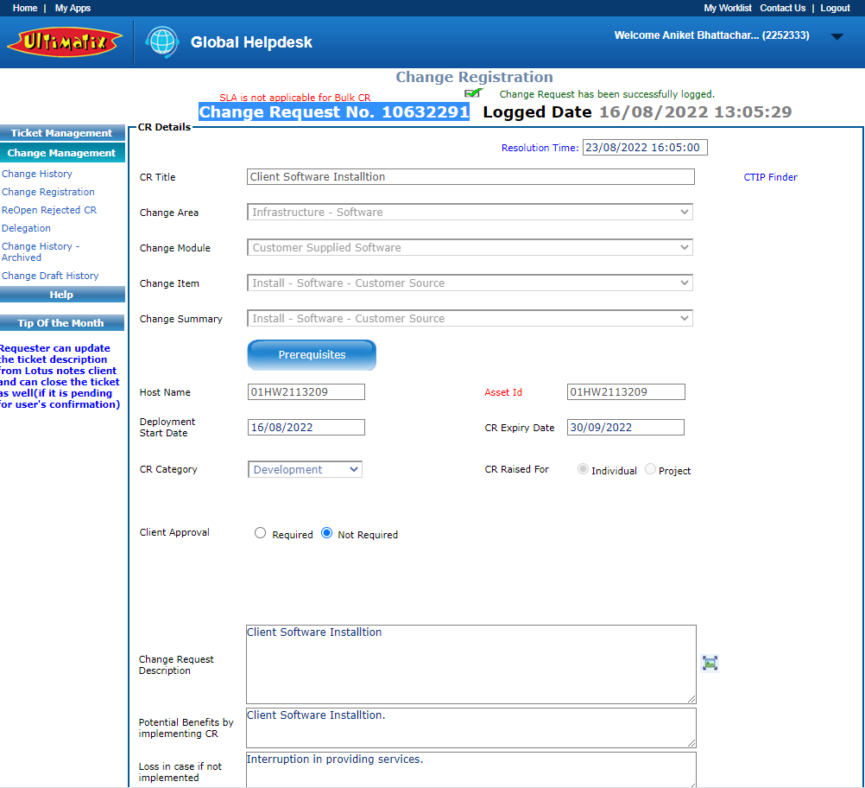

=========================************************==============

NPT- non productive time

KPI- key performance indicator

PLC -Programmable logic controller

**Open Platform Communications** (OPC)

